**INTERNSHIP REPORT**

**On**

**AR ENABLED GREETING CARDS**

**By**

**S.Venkata Kishore – BU22CSEN0500219**

**K.Tharun Reddy - BU22CSEN0500222**

**V.Kiran Kumar Reddy -BU22CSEN0500123**

**COMPANY NAME /CERTFICATION COMPANY**

**INTN2333**

**(Duration: 28.11. 2024 to 22.03.2025)**

**DEPARTMENT OF COMPUTER SCIENCE AND ENGINEERING**

**Gandhi Institute of Technology and Management**

**(DEEMED TO BE A UNIVERSITY)**

**BENGALURU, KARNATAKA, INDIA**

**SESSION:2020-2024**

**DEPARTMENT OF COMPUTER SCIENCE AND ENGINEERING**

**GITAM SCHOOL OF TECHNOLOGY**

**GITAM**

**CERTIFICATE**

This is to certify that the mini project report entitled **“AR ENABLED GREETING CARDS”** is a bonafide record of work carried out by **S Venkata Kishore (BU22CSEN0500219), K. Tharun Reddy (BU22CSEN0500222), V.Kiran Kumar (BU22CSEN0500127)** submitted in partial fulfillment of requirement for the award of degree of **Bachelor of Technology in Computer Science and Engineering**.

Name of Guide : Dr. N. GANESH KUMAR

Assistant Professor

Department of CSE

GST, Bengaluru

**ACKNOWLEDGEMENT**

The satisfaction and euphoria that accompany the successful completion of any task would be incomplete without the mention of the people who made it possible, whose consistent guidance and encouragement crowned our efforts with success.

We consider it our privilege to express our gratitude to all those who guided us in the completion of the project.

We express our gratitude to Director Prof. **Basavaraj Gundappa Katageri** for having provided uswith the golden opportunity to undertake this project work in their esteemed organization.

We sincerely thank **Dr. A. Vadivel,** HOD, Department of Data Science, Gandhi Institute of Technology and Management, Bengaluru for the immense support given to us.

We express our gratitude to our project guide **Dr. N**. **Ganesh Kumar, Assistant Professor**, Department of Computer Science and Engineering, Gandhi Institute of Technology and Management, Bengaluru, for their support, guidance, and suggestions throughout the project work.

Student Name : S.VENKATA KISHORE -BU22CSEN0500219

K.THARUN REDDY- BU22CSEN0500222

V.KIRAN KUMAR- BU22CSEN0500127

**contents**

**Title page no.**

Internship I

Acknowledgement II

About the Internship Course III

Table of Contents IV

Abstract V

List of Figures VI

1.INTRODUCTION 6

2. PROJECT OVERVIEW 7

3. SETTING UP THE UNITY PROJECT 10

4. KEY FUNCTIONS OF AR CARD 13

5. KEY FEATURES 14

6. FUTURE SCOPE 15

7. RESULTS 16

8.CONCLUSION 17

**Abstract**

This project presents the development of an Augmented Reality (AR) enabled greeting card application for the Diwali event. Utilizing the Vuforia engine in Unity, the application transforms traditional Diwali greeting cards into interactive digital experiences. By scanning a physical greeting card using a mobile device, users can view 3D animations, hear festive sounds, and engage with immersive visuals.

The project involves setting up an AR environment, designing and importing image targets, integrating 3D models and audio, and building the final application as an Android (.apk) file. This initiative enhances the cultural significance of Diwali celebrations by merging traditional and modern technologies. The application provides an innovative way of connecting people through personalized and interactive greeting cards.

The report outlines the complete development process, including the software tools used, project challenges, and the results achieved. Additionally, recommendations for future improvements and applications of AR in other festive events are discussed. This project serves as a testament to the transformative potential of AR technology in preserving and enhancing cultural traditions.

**LIST OF FIGURES :**

**FIGURE -1 :- Unity Menu**

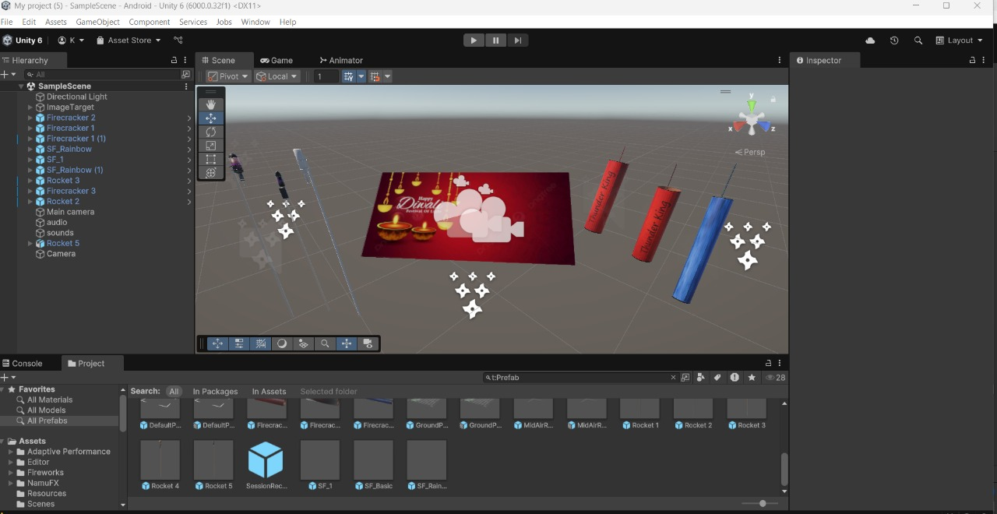

**FIGURE-2:- Stimulation**

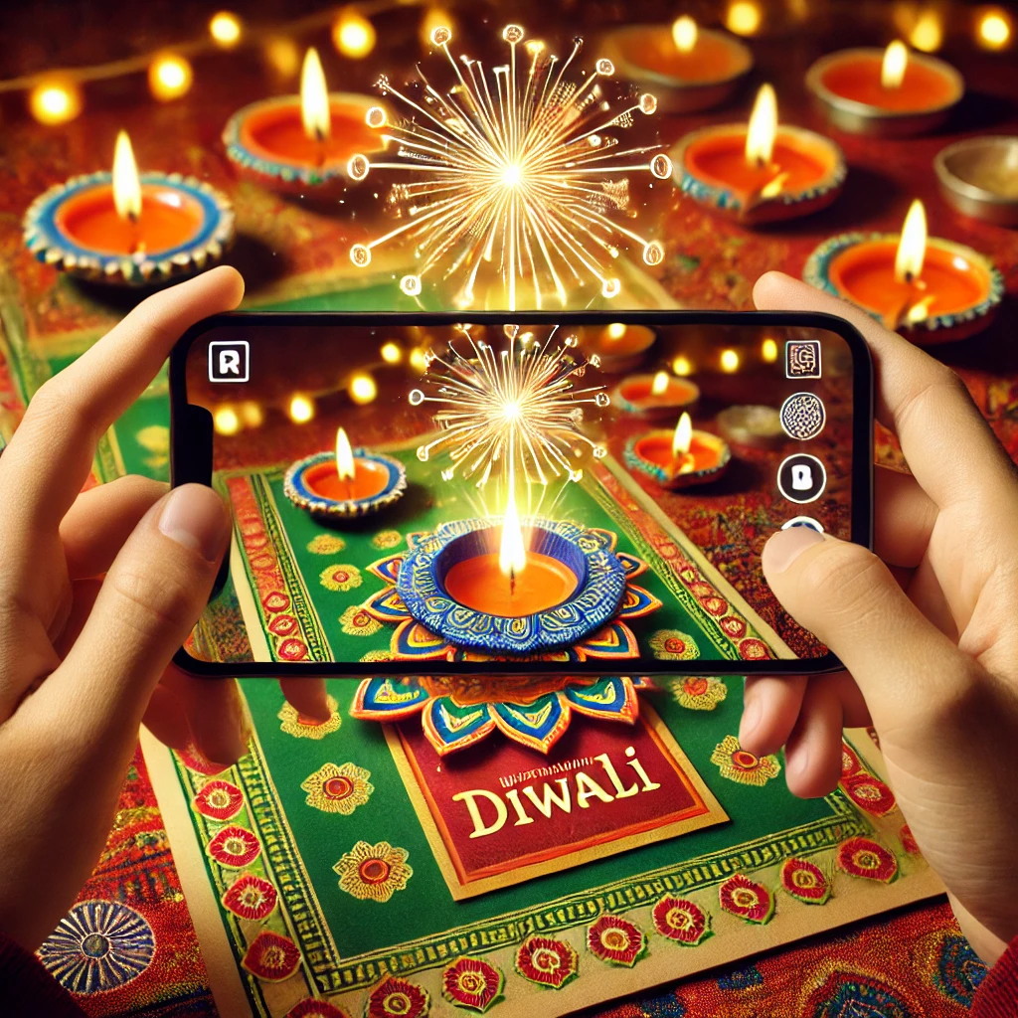

**1.INTRODUCTION**

Augmented Reality (AR) is a rapidly growing technology that superimposes digital content onto the real world through a device's camera. It bridges the gap between the digital and physical worlds, enhancing the user experience with interactive and immersive elements. AR has gained popularity in various fields, including gaming, education, marketing, and entertainment. With the increasing availability of smartphones and AR-compatible devices, this technology is becoming accessible to a broader audience.

In the context of traditional celebrations like Diwali, AR introduces a novel way of enhancing festive experiences. Diwali, the festival of lights, is a significant celebration in Indian culture, symbolizing the victory of light over darkness and good over evil. Greeting cards are a traditional medium for expressing festive wishes during this time. Over the years, the evolution of digital media has transformed the way people convey their emotions. AR-enabled greeting cards take this concept further by adding interactive elements that create a memorable and engaging experience for users.

The integration of AR into greeting cards provides an opportunity to make celebrations more personalized and entertaining. By using an AR-enabled application, users can scan the Diwali card and experience real-time visual effects, animations, and audio that enhance the festive spirit. This approach not only modernizes the concept of greeting cards but also offers a sustainable, digital alternative to traditional paper cards.

Furthermore, AR technology can be used to include educational or cultural content, such as the stories and significance of Diwali. This makes the experience not only enjoyable but also informative. The use of Unity and Vuforia Engine for this project allows seamless development and implementation of AR features, ensuring an efficient and immersive

users experience.

This project demonstrates how AR can bring traditional celebrations to life in an innovative manner. By leveraging AR technology, users can interact with digital content in their physical environment, making the celebration of Diwali.

**2.** **PROJECT OVERVIEW**

The AR-enabled Diwali greeting card project involves a systematic development process, divided into key stages. Each stage contributes to ensuring a seamless and engaging augmented reality experience.

1.Conceptualization and Design:

* + The project began with brainstorming the concept of enhancing Diwali greeting cards using AR.
  + Design considerations included festive themes, interactive animations, and user-friendly experiences.
  + Storyboarding was done to visualize the AR experience, incorporating traditional Diwali elements like diyas, rangoli, and fireworks.

1. Image Target Selection:
   * A visually appealing Diwali-themed image was created and selected as the image target.
   * Vuforia Engine was used to recognize and track the image, ensuring reliable performance.
2. Vuforia Database Creation:
   * The Diwali card image was imported into the Vuforia Target Manager, where a database was created for storing the image target.
   * The generated database was then downloaded and integrated into Unity for further development.
3. Unity Environment Setup:
   * Unity was used as the primary development platform to create and manage the AR application.
   * The Vuforia Engine package was imported into Unity, establishing the necessary environment for image recognition and tracking.
4. Adding AR Content:
   * Festive 3D models, particle effects, and animations were added to the Unity scene.
   * Visual effects such as glowing diyas, animated fireworks, and decorative lanterns were integrated to enhance the experience.
   * Background music and sound effects representing Diwali celebrations were implemented.
5. Interaction and User Experience:
   * Basic interactivity was introduced, such as tapping on certain elements to trigger additional animations.
   * The user interface was designed to ensure ease of use, with minimal controls and a focus on the AR experience.
6. Testing and Optimization:
   * Extensive testing was conducted on various Android devices to ensure compatibility and performance.
   * Adjustments were made to optimize rendering quality, animation fluidity, and responsiveness.
7. APK Generation and Deployment:
   * Once development was complete, the application was built and packaged as an APK file using Unity.
   * The APK was tested for installation, functionality, and usability on Android devices.

**3. SETTING UP THE UNITY PROJECT**

**Setting Up the Unity Project:** The following steps were followed to set up the Unity project:

1. **Install Unity and Vuforia:**
   * Download and install Unity Hub and Unity Editor.
   * Install the Vuforia Engine SDK from the Vuforia Developer Portal.
   * Create a new Unity project with a 3D template.
2. **Create a Vuforia License Key:**
   * Sign up on the Vuforia Developer Portal.
   * Create a new project and generate a license key.
   * Copy the license key and add it to Unity via the Vuforia Configuration component.
3. **Set Up Image Target:**
   * Select the image to be used as a marker for AR interaction.
   * Upload the image to Vuforia's Target Manager and generate a database.
   * Download and import the database into Unity.
4. **Configure Unity for Vuforia:**
   * In Unity, navigate to Edit > Project Settings > XR Plugin Management and enable Vuforia.
   * Add an AR Camera to the scene and configure it using Vuforia's AR Camera settings.
   * Drag and drop the image target prefab into the scene and assign the appropriate image from the imported database.
5. **Add AR Content:**
   * Import 3D models, animations, or particle effects using Unity’s asset store or external tools.
   * Position the content relative to the image target.
   * Add animations and visual effects, like fireworks or glowing lamps, for a festive touch.
6. **Add Audio and Interactivity:**
   * Import Diwali-themed music and sound effects.
   * Use Unity’s AudioSource component to play background music and sound effects.
   * Implement C# scripts to control interactions, animations, and user engagement.
7. **Build and Test:**
   * Connect an Android device via USB.
   * In Unity, go to File > Build Settings, select Android, and configure the build settings.
   * Generate the APK file and install it on the device for testing.

**4.** **Key Functions of the AR Diwali Card App**

The application includes several functions for providing an interactive and immersive experience:

1. **Image Recognition Function:**
   * Vuforia uses computer vision technology to detect and recognize the Diwali card using the device's camera.
   * Once the image is identified, the AR content is rendered in real-time using the Unity engine.
2. **Animation Playback Function:**
   * Upon recognizing the image target, the application triggers festive animations like fireworks, glowing diyas, and traditional Diwali elements.
   * These animations are created using Unity’s animation system and are synchronized with audio effects.
3. **Audio Management Function:**
   * Background music and celebratory sound effects are played using Unity’s AudioSource component.
   * Users can hear the sound effects of fireworks, traditional Diwali songs, or mantras.
4. **User Interaction Function:**
   * Users can interact with the AR content using touch gestures or on-screen buttons.
   * Example interactions include tapping on the screen to trigger additional animations or lighting more diyas.
5. **Lighting and Rendering Control Function:**
   * Unity’s lighting system is used to adjust the illumination on AR objects, simulating realistic Diwali lighting.
   * Dynamic lighting effects, like flickering diya flames and glowing effects, enhance visual appeal.

**5. Exciting Features of the AR Diwali Card**

**AR-Enabled Interaction:** Users can experience traditional Diwali cards with interactive AR elements.

* **3D Animations:** Realistic animations of fireworks, diyas, and rangoli are displayed on scanning the card.
* **Audio Integration:** The app features immersive sound effects and Diwali-themed background music.
* **Real-Time Tracking:** Vuforia ensures accurate recognition and real-time rendering of AR content.
* **User-Friendly Interface:** Simple and intuitive navigation for users of all age groups.
* **Cross-Device Compatibility:** The app is designed to work seamlessly across Android smartphones and tablets.
* **Engaging Visual Effects:** Dynamic lighting and particle effects provide a festive and joyful experience.
* **Interactive Elements:** Users can interact with AR objects through taps and gestures to trigger animations and sounds.
* **Offline Functionality:** Once installed, the app can work without requiring an internet connection.

**6.** **Future Scope**

* **Multi-Festival Support:** Expand the application to support other festivals such as Christmas, Eid, or New Year, with customized animations and sound effects.
* **Personalized Greetings:** Allow users to add personalized messages, photos, and videos that can be embedded into AR experiences.
* **Multi-Language Support:** Offer language customization for users across different regions, enhancing accessibility and engagement.
* **Social Media Integration:** Provide options to share AR greetings on social media platforms directly from the app.
* **E-commerce Integration:** Enable users to purchase customizable AR cards and digital gifts through the app.
* **Gamification:** Add interactive mini-games or challenges as part of the AR experience for increased user engagement.
* **Cloud Storage:** Implement cloud-based storage to save personalized cards and access them across multiple devices.

**7. Results**

The AR-enabled Diwali greeting card application effectively demonstrated the integration of AR into traditional festivities. Users found the experience engaging and visually appealing. The application exhibited high accuracy in image recognition, with minimal latency in rendering animations and sound effects. The vibrant visuals and immersive audio effects significantly enhanced the overall user experience. Additionally, the app received positive feedback for its user-friendly design and seamless functionality. The application’s ability to evoke emotional connections through personalized festive greetings further highlighted its success.

Users appreciated the novelty of experiencing augmented reality through a simple greeting card, making it an enjoyable addition to Diwali celebrations. The app’s performance remained stable across different Android devices, ensuring accessibility and inclusivity.

**8. Conclusion**

The AR-enabled Diwali greeting card project successfully merged technology with tradition, offering an interactive and memorable way to celebrate festivals. Through the effective use of Unity and Vuforia, the application created an immersive AR experience with stunning visuals and engaging audio. By fostering emotional connections and enhancing the festive spirit, the project highlighted the potential of AR technology in cultural and celebratory contexts.

Moving forward, further enhancements such as multi-festival support, personalization options, and social media integration can extend the application’s appeal. This project serves as a stepping stone for innovative AR applications in the cultural and entertainment sectors, encouraging more interactive and meaningful experiences.

Signature Of Mentor